**DAILY ONLINE ACTIVITIES SUMMARY**

|  |  |  |  |  |  |
| --- | --- | --- | --- | --- | --- |
| **Date:** | | **23/06/2020** | **Name:** | **JASLINE SHARON TAURO** | |
| **Sem & Sec** | | **4th sem, A Section** | **USN:** | **4AL18CS029** | |
| **Online Test Summary** | | | | | |
| **Subject** | **----** | | | | |
| **Max. Marks** | **----** | | **Score** | **----** | |
| **Certification Course Summary** | | | | | |
| **Course** | | Web Development Engineer | | | |
| **Certificate Provider** | | **AWS Educate** | **Duration** | | **3 hrs.** |
| **Coding Challenges** | | | | | |
| **Problem Statement:**   1. Write a C Program to Sort a stack using a temporary stack. 2. Python Program to Split the array and add the first part to the end There is a given an array and split it from a specified position, and move the first part of array add to the end. | | | | | |
| **Status: EXECUTED** | | | | | |
| **Uploaded the report in GitHub** | | | **YES** | | |
| **If yes Repository name** | | | <https://github.com/jaslinesharontauro/C_Prgms>  <https://github.com/jaslinesharontauro/Python-coding> | | |
| **Uploaded the report in slack** | | | **YES** | | |

Online Test Details: (Attach the snapshot and briefly write the report for the same)

Certification Course Details: (Attach the snapshot and briefly write the report for the same)

Coding Challenges Details: (Attach the snapshot and briefly write the report for the same)

CERTIFICATION COURSE DETAILS:

Today I have started the new course “Web Development Engineer” by AWS Educate. In this course today I learnt about Introduction and about programming and scripting. And I have also completed the assessment of this module.

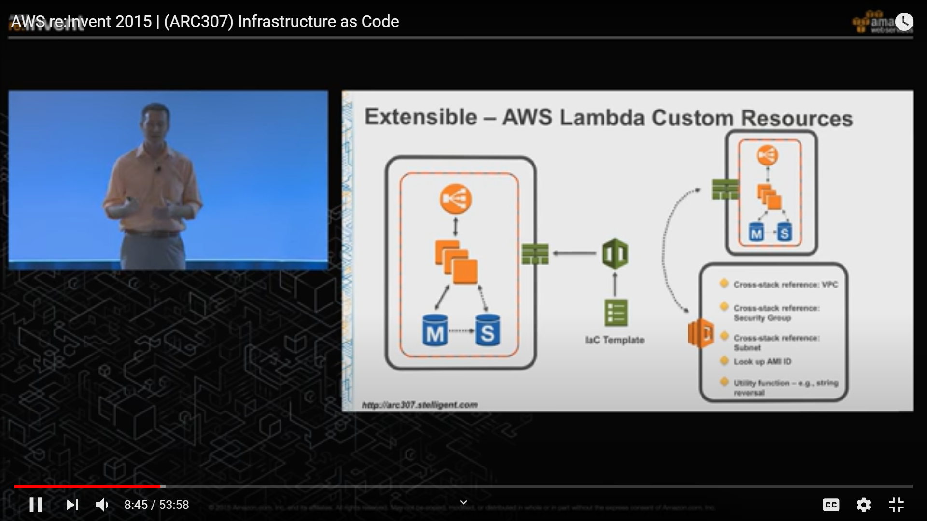

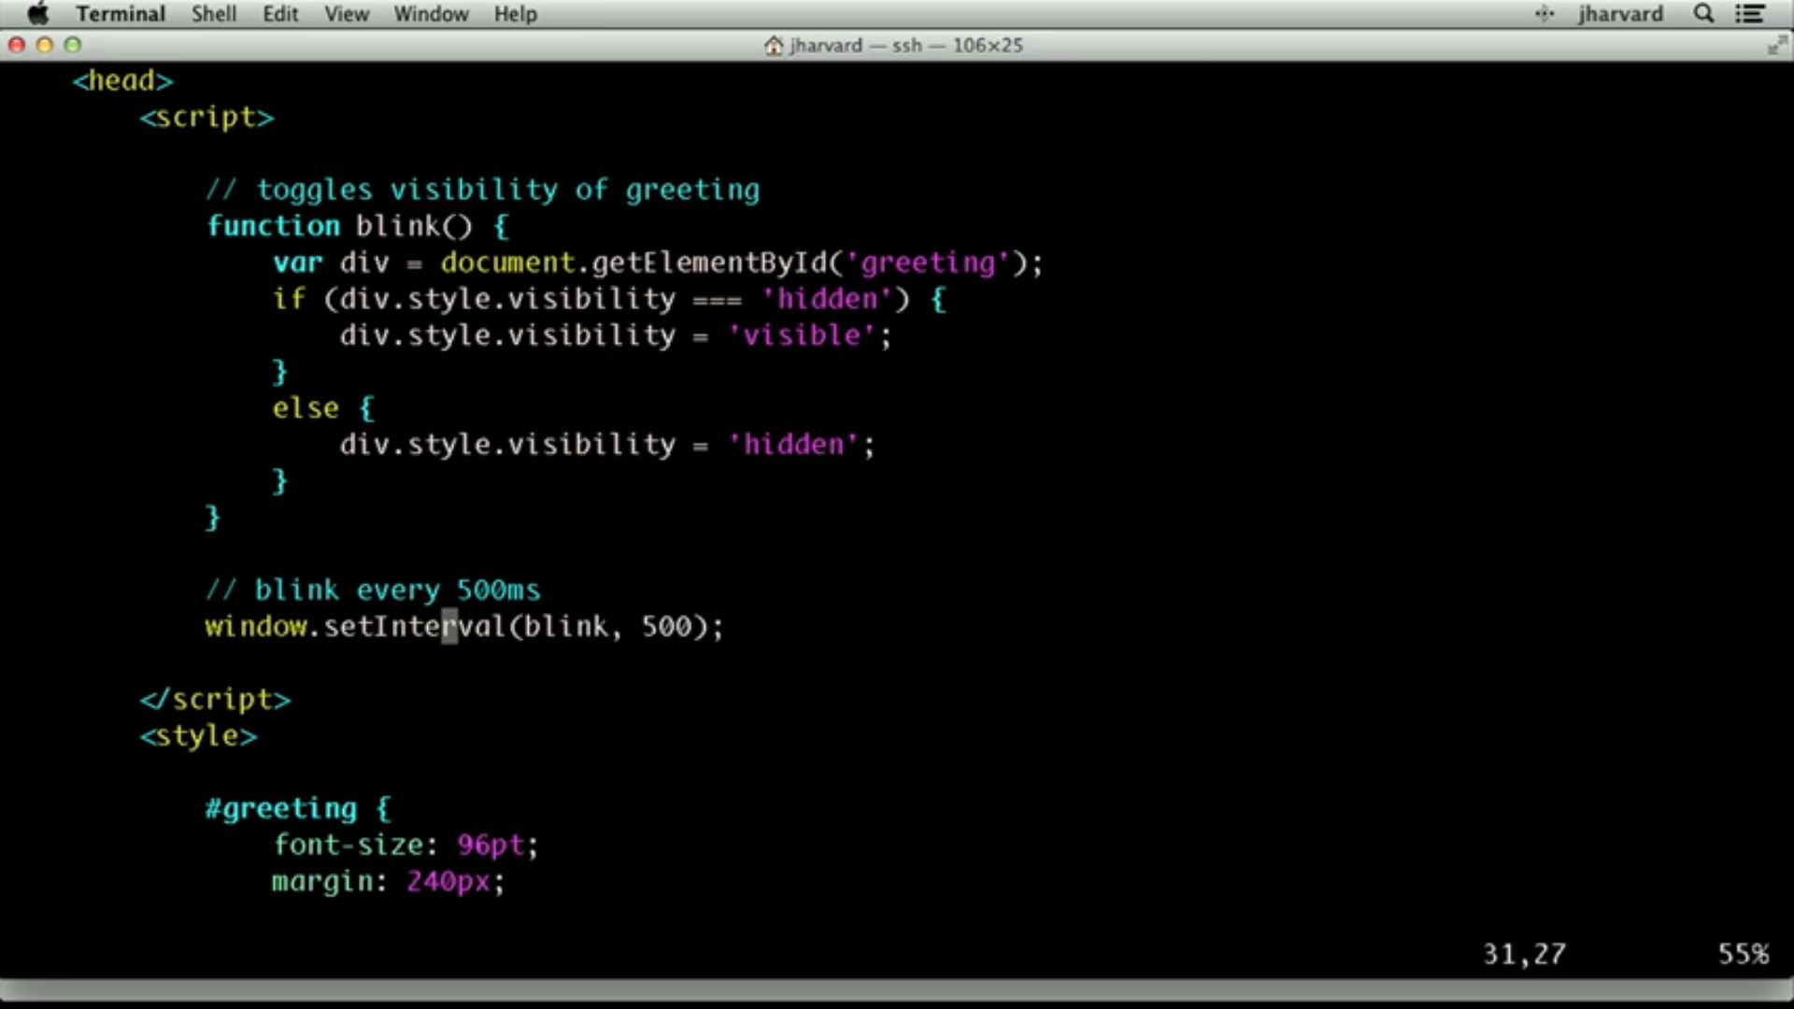

WEBINAR DETAILS:

Today I have attended the webinar on “INTERNET OF THINGS-OPPORTUNITIES AND CHALLENGES” by Prof.Sushant, CSE department- AIET. The session was very interesting. There was assessment conducted based on the webinar. The test was of MCQ type, there were 15 number of questions of ONE mark each out of which I scored 10.

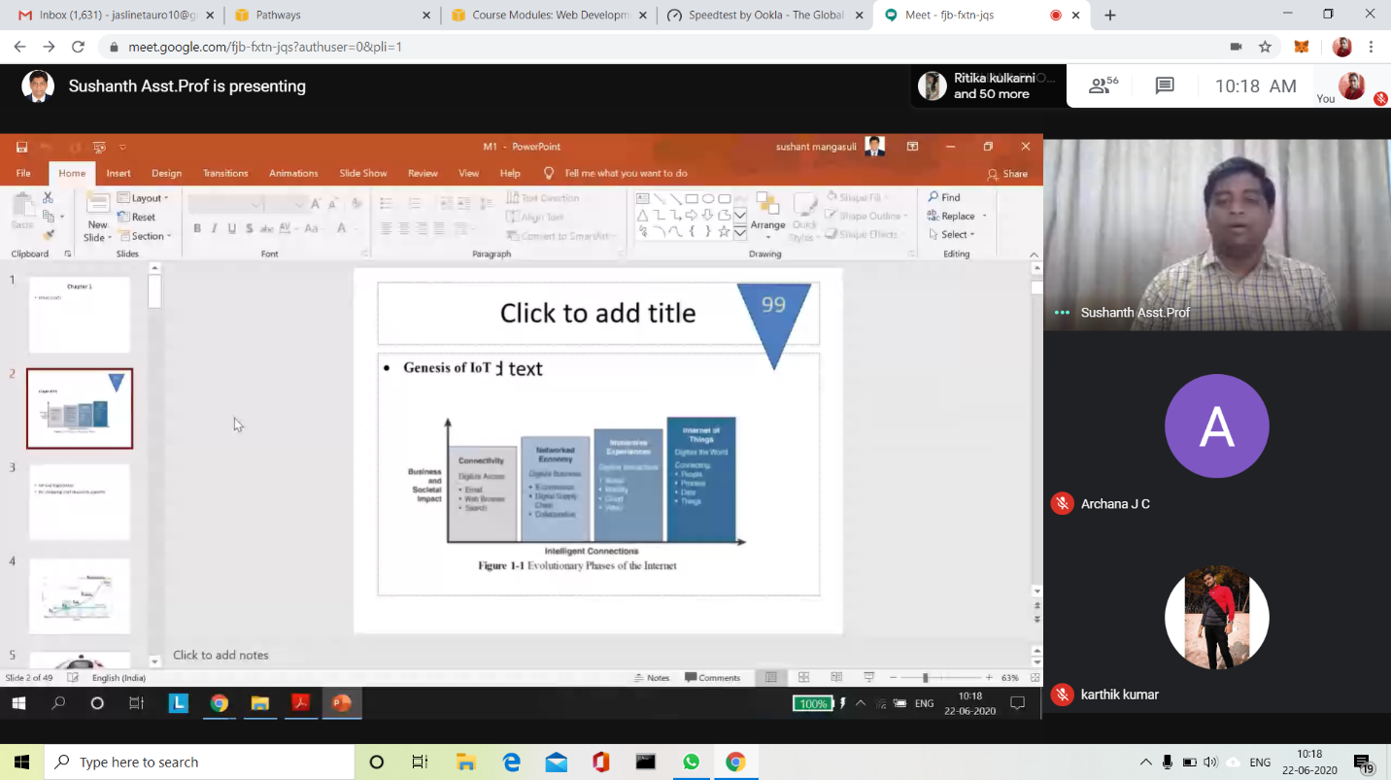

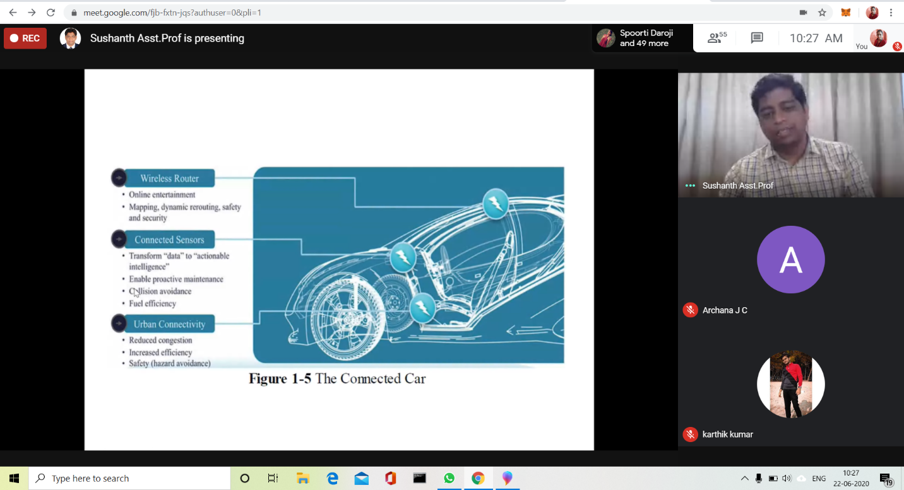

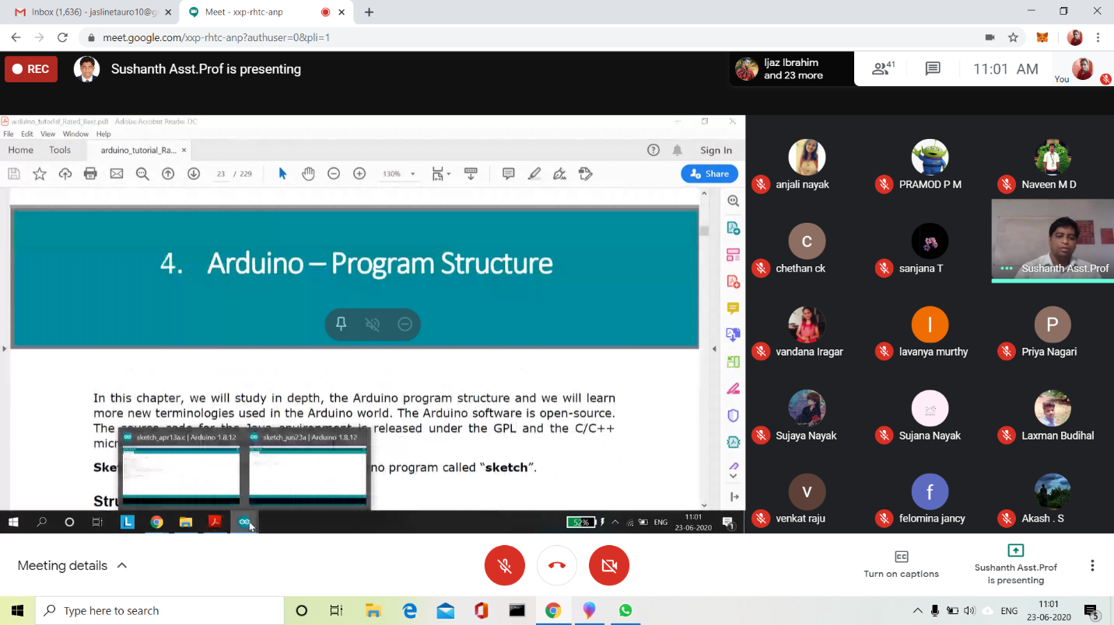

CODING CHALLENGES:

Problem Statement 1:

Write a C Program to Sort a stack using a temporary stack.

We follow this algorithm.

1. Create a temporary stack say tmpStack.
2. While input stack is NOT empty do this:  
   • Pop an element from input stack call it temp  
   • while temporary stack is NOT empty and top of temporary stack is greater than temp,  
   pop from temporary stack and push it to the input stack  
   • push temp in temporary stack
3. The sorted numbers are in tmpStack

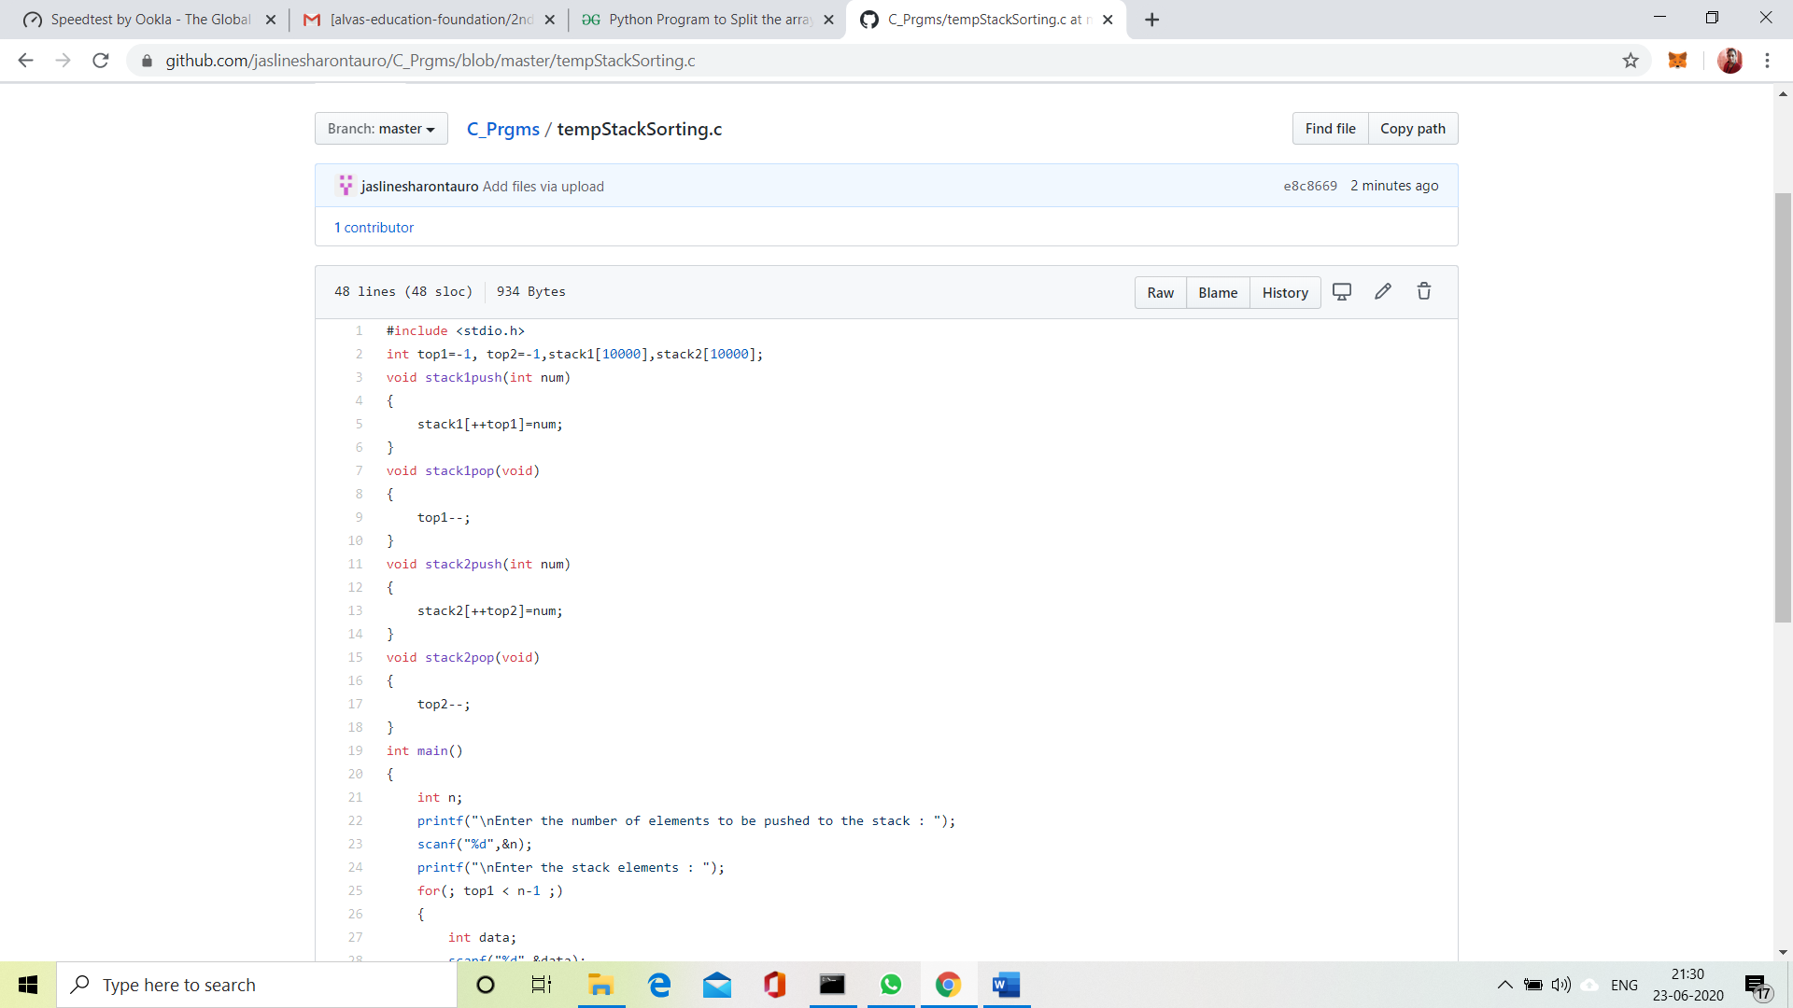

 Solution uploaded in GitHub.

Problem Statement 2:

Python Program to Split the array and add the first part to the end There is a given an array and split it from a specified position, and move the first part of array add to the end.

Examples:

Input: arr [] = {12, 10, 5, 6, 52, 36}  
k = 2  
Output: arr [] = {5, 6, 52, 36, 12, 10}  
Explanation: Split from index 2 and first  
part {12, 10} add to the end.

Input: arr [] = {3, 1, 2}  
k = 1  
Output: arr [] = {1, 2, 3}  
Explanation: Split from index 1 and first  
part add to the end.

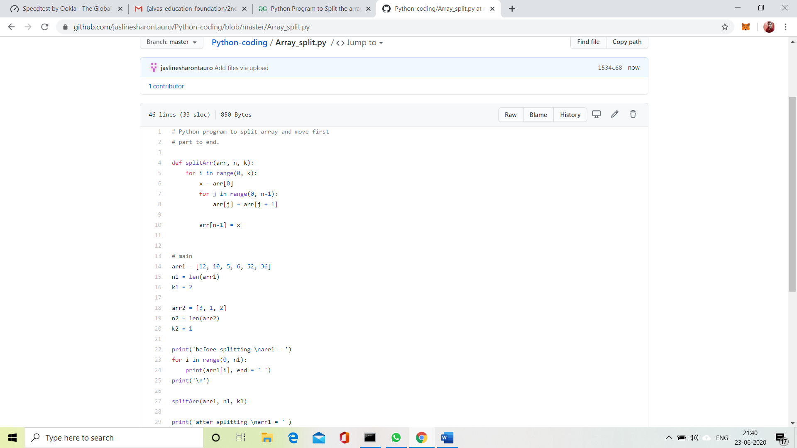

Solution uploaded in GitHub.